**Assessment 3: Microchip voltage**

Goal 1: A chart of the voltages at the first five locations for $0 < n < 120$, where $n$ is the time in milliseconds.

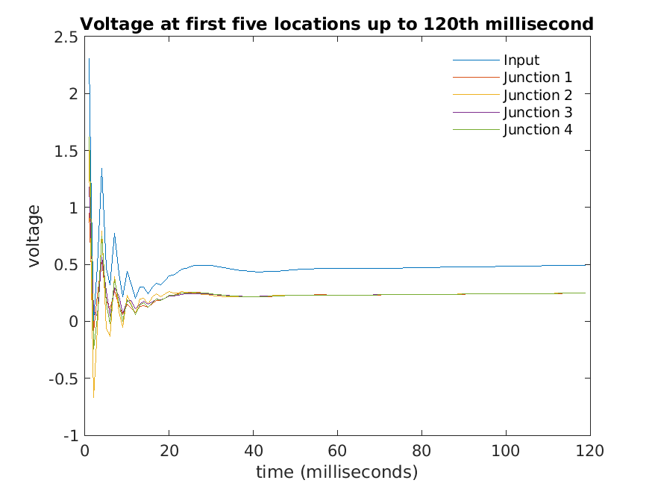

Goal 2: All 21 voltages corresponding to the 120th millisecond after the voltage spike. This has also been attached as a separate file to the submission (*‘Goal_2.txt’*).

4.9463149e-01

2.4759154e-01

2.4807587e-01

2.4774440e-01

2.4768369e-01

2.4766554e-01

2.4748230e-01

2.4781996e-01

2.4786202e-01

2.4782639e-01

2.4771507e-01

2.4804753e-01

2.4755190e-01

2.4761335e-01

2.4785110e-01

2.4781095e-01

2.4732928e-01

2.4751588e-01

2.4785458e-01

2.4798953e-01

2.4729289e-01

Goal 3: A comparison of the values of the eigenvector corresponding to the largest eigenvalue, with the results from the time evolution, and commentary on what is the same.

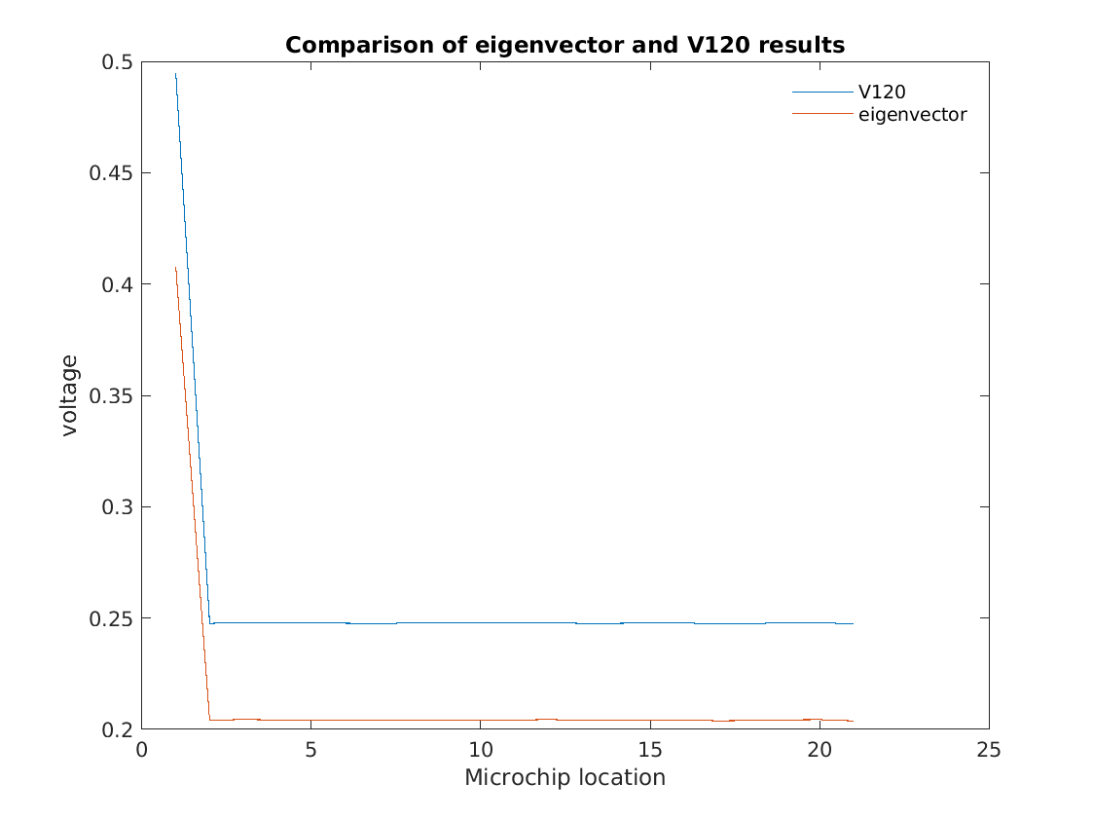

As the chart shows, the pattern of voltage levels across the 21 microchip locations are the same i.e. it drops dramatically after the input location and is the roughly the same level across the 20 junctions. On the other hand, the voltage levels are consistently much smaller for the eigenvector compared to the result from the time evolution.

Goal 4: A chart of the values of ${\tilde{V}}_{n}$ as circles on top of the values of $V_{n}$ as lines for $n = 98$ to $n = 120$.

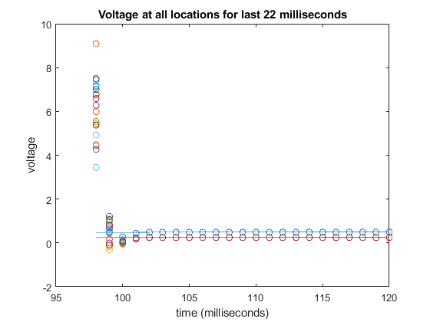

Goal 5: A comparison of the forwards in time-calculated voltages with the backtracked values for $n = 98$ 
 to $n = 120$.

The voltages produced by the two different approaches (forward and backtracked) are nearly indistinguishable for all locations on the microchip until $n = 101$. For this time point and the previous one ($n = 10$), the voltages produced by backtracking are increasingly smaller in magnitude (on average) than the voltages produced by the forward approach. However, for time points $n = 98$ and $n = 99$, this abruptly changes. At time point $n = 99$, most of the backtracked voltages are larger than those produced by the forward approach. At $n = 98$, all are much larger by a relatively high order of magnitude.

This sudden divergence is a possible indication of an issue with the backtracking approach of calculating voltages for different locations in the microchip. The reason for this, as stated in step 12, is that the problem was ill-posed.

Goal 6: The condition numbers of $A$ and $A^{-1}$.

The condition numbers of $A$ and $A^{-1}$ are exactly the same; that is, $A=A^{-1}=6.9928×{10}^{3}.$ This condition value is quite large, which means that the error will increase very quickly in calculations.

Goal 7: The value of the largest (in absolute terms) eigenvalues for $A$ and $A^{-1}$, and commentary on how they are different.

$$eigenvalue\left(A\right)=1.0012+0.0000i$$

$eigenvalue\left(A^{-1}\right)=1.4263+4.8038i$

The value of the largest eigenvalue for matrix $A$ is a real number, but the largest eigenvalue for $A^{-1}$ has both a real and complex part (and is larger in magnitude than the eigenvalue for matrix $A$).

Goal 8: A csv file containing the values of $V_{n}$ for $n = 0$ to $n = 120$ and ${\tilde{V}}_{n}$ for $n = 98$ to $n = 120$. This has been attached as a separate file to the submission (*‘Voltages.csv’*). Note that the matrix array in the file was coded such that it includes columns filled with zeros for the voltages of ${\tilde{V}}_{n}$ for $n = 0$ to $n = 97$ 
 for completeness.